Essential Surgical Techniques Key Procedures
Storyboard Tool

Authors are strongly encouraged to complete this storyboard form and submit it for provisional peer review prior to producing your video to minimize post-production editing. After your storyboard has been approved, use it as the overall guide for video production and narration. Total video duration is typically ten to fifteen minutes.

Please do not include video clips in this storyboard. Any images used for the storyboard should be still photographs or line drawings only.

ABSTRACT

Provide a written abstract (maximum, 325 words), which will be published online as text accompanying the video. The Abstract should include:

(1) a brief overall description of the procedure: purpose (what it does), indications (for what and for whom it is performed), and description (how it works)
(2) a list of the steps of the procedure, with a single sentence summarizing each step (e.g., Step 1: Incision. Make a transverse plantar skin incision distal to the metatarsal weight-bearing area, Step 2: . . .)
(3) the expected outcome of the procedure

Osteoid osteomas can usually be diagnosed with confidence on the basis of radiographs combined with computed tomography (CT) and/or magnetic resonance imaging (MRI) that demonstrate the nidus lesion. Although symptoms may resolve spontaneously, persistence of pain is the main indication for surgical intervention that causes most patients to seek treatment. Radiofrequency ablation (RFA) is the current standard of care for most lesions unless nearby neurologic structures (e.g., the spinal cord) are at risk for injury. RFA is performed in a minimally invasive manner by placing a radiofrequency probe into the center of the nidus and heating the probe to 90°C for six minutes, thereby killing the neoplastic cells, which elaborate inflammatory cytokines that are believed to cause pain. Success, defined as pain relief, depends on the accuracy of the placement of the probe into the nidus. Multiple studies have shown success in >90% of patients. The use of surgical navigation, combined with intraoperative cross-sectional CT imaging, can both facilitate probe placement and reduce radiation exposure. The major steps of the procedure, which are demonstrated in this video article, are (1) placement of an infrared tracking array, (2) performance of an intraoperative CT scan for export to the surgical navigation software, (3) registration of the Kirschner-wire guide, (4) placement of the Kirschner wire, (5) exchange of the Kirschner wire for the RFA probe, (6) performance of CT to confirm probe placement, and (7) performance of the RFA burn. Complications are rare, and an immediate return to normal activity is possible.

Instructions for Slide/Scene Descriptions and Narration

Please follow these instructions for all of the following boxes:
- In the left box, provide a DESCRIPTION OF A TEXT SLIDE OR VIDEO SCENE (or an image representing the slide or scene).
- In the opposing right box, insert the actual SCRIPT OF THE NARRATION that will accompany each text slide or video scene. Each box describing a slide or scene should be accompanied by a box with the narration for that slide or scene.
- Please do not copy and paste text from the reference article(s) into this form.
- Please do not include video clips in this storyboard. Any images used for the storyboard should be still photographs or line drawings only.
- Recommended times for each video chapter have been provided, but you may change them as necessary.
- Append rows to this table if you wish to include more than one text slide or video scene.
Video File 1
PROCEDURE TITLE (5 sec)  Insert here:  Radiofrequency Ablation of Osteoid Osteoma using Intraoperative 3D imaging and Surgical Navigation | Narration optional.
AUTHORS AND AFFILIATIONS (5 sec)  Insert here:  Edward Y. Cheng, MD; Sameer M. Naranje, MBBS, MRCS(Glasgow); E. Russell Ritenour, PhD | Narration optional.
REFERENCE PAPER(S) (5 sec):  Provide full citation(s) of the articles(s) on which this video article is based here:  Radiation Dosimetry of Intraoperative Cone-Beam Compared with Conventional CT for Radiofrequency Ablation of Osteoid Osteoma  Edward Y. Cheng, MD; Sameer M. Naranje, MBBS, MRCS(Glasgow); E. Russell Ritenour, PhD  J Bone Joint Surg Am, 2014 May 07;96(9):735-742. http://dx.doi.org/10.2106/JBJS.M.00874 | Narration optional.
INTRODUCTION OF VIDEO BY AUTHOR SPEAKING ON CAMERA (30-60 sec)  Indicate here if you will deliver the introduction in the operating room, office, examining room, or other location:  Operating room setting. | Explain to the viewer the purpose of making this video, the importance of the procedure, how the procedure has evolved to this point, etc.:  There are three advances that facilitated the development of performing radiofrequency ablation in the operative setting. The first is that surgeons traditionally only had two-dimensional fluoroscopic imaging for surgical guidance. Now with the development of intraoperative CT scans such as the O-arm unit here, repeated CT scans can be performed on the fly in the operating room as needed. Secondly, real-time surgical navigation is possible using infrared optical tracking arrays. These are typically attached to the target, as well as to surgical hand pieces that allow the surgeon to manipulate the hand piece relative to the anatomic target. The third is the development of cone beam CT technology which, results in a reduced radiation dose exposure to the patient as compared to conventional 64-slice CT scanners. In this video I hope to show you how to perform this procedure and the particular steps that are necessary to perform it safely and efficiently.
Video File 2
GENERAL INTRODUCTION (1-2 min)  In this box, describe the video scene to be shown. If a text slide is to be used, a copy of the slide is acceptable.  Radiofrequency ablation for osteoid osteomas: background  - Osteoid osteoma (OO) - benign bone tumor, 3-4% of all bone tumors, 11–12% of benign bone tumors  - Age: 5 to 20 years, males > females  - Natural history: spontaneous resolution  - Rx: ASA and NSAID’s  - Surgery:  - excision (en bloc or curettage)  - radiofrequency | Discuss background information and foundational knowledge, indications, importance and relevance of the procedure in the management of specific conditions. Also discuss the context of the procedure in relation to other similar procedures here:  “Osteoid osteomas are an unusual bone tumor and represent 3-4% of all bone tumors. However, among the benign bone tumors, they represent 11-12%. ➔Patients typically are adolescents or young adults, and there is a slight predilection for males. Nearly all patients have non-activity-related pain. ➔The natural history is for spontaneous resolution to occur, but this may take many years. ➔Characteristically, aspirin or anti inflammatory agents relieve the pain, but one must continue to take medications for many years. For this reason, most patients choose to have surgical treatment. ➔In the past, this consisted of surgical excisions, either by en bloc resection or intralesional curettage. However, currently, radiofrequency ablation is considered the standard of care. This radiograph shows a typical osteoid osteoma in the lateral cortex of the proximal humerus. The coronal CT scan clearly demonstrates the lesion and the axial CT also shows the nidus within the anterolateral humeral cortex.”
Virtual image & CT image | “The top screen in blue color represents the surgeon’s view of the virtual image, demonstrating the position of surgical instruments being navigated in the surgical field relative to the target nidus. The bottom screen represents the CT scan image formed after 3-dimensional reconstructions using the O-arm software. In this particular case, the placement of two K-wires, best seen in the 2 CT images on the right, is confirmed within the nidus inside the humerus.”
Indications for RFA  - Symptomatic patients with osteoid osteomas  - Sx’s unresponsive to analgesics (ASA or NSAID’s)  - If sx’s are responsive to meds, a prolonged course of treatment may be undesirable  - Secondary deformity (eg, scoliosis) | “The indications for radiofrequency ablation are patients with painful osteoid osteomas, patients with symptoms unresponsive to analgesics, or patients in whom symptoms are responsive to medication but a prolonged course of treatment is considered undesirable. Finally, in rare cases, a secondary deformity may develop, such as a scoliosis.”
Importance of RFA  - Surgical excision involves curettage, en bloc resection or wide resection and bone grafting with success rates of 90–100%  - But, complications as high as 20% in some series with a 4.5% incidence of fractures  - RFA is minimally invasive, has higher success in relieving pain (>92%) with a lower risk of complications (<1%) | “The importance of radiofrequency ablation relative to other treatment options is that surgical incision involves curettage, en block resection or wide resection and bone grafting, and success rates of 90-100% are reported. However, there are complications as high as 20% in some series, with a 4.5% incidence of fractures. Radiofrequency ablation is advantageous in that it is minimally invasive, is successful in relieving pain in over 92% of patients, and has a lower risk of complications than surgical excision.”
Surgical navigation  - Optical infrared camera  - Tracking array on target and hand instrument  - Real time  - Virtual image  - No radiation emitted during navigation | “In surgical navigation, an optical infrared camera is used to track a target attached to an optical array. These arrays are attached to the target and any surgical instruments. The advantage of surgical navigation is the ability to see the target continuously, in real time, on a virtual image, without any radiation being emitted. Three common platforms for surgical navigation are the Medtronic StealthStation®, Brainlab, and Stryker’s navigation suite.”
Types of CT: Cone Beam (O-arm) | “The O-arm uses cone beam CT technology. This emits only half the radiation dose of a conventional CT. Image contrast is excellent and bone visualization is superb. However, soft tissues are poorly seen. A conventional 64-slice CT scanner emits a higher radiation dose yet provides diagnostic-quality images of both bone and soft tissue.”
Types of CT: Conventional CT | “A conventional 64-slice CT scanner emits a higher radiation dose yet provides diagnostic-quality images of both bone and soft tissue.”
O-arm CT image | “This is the typical image seen from an O-arm CT scanner that has been reformatted in three dimensions. Coronal, axial and sagittal views are available to interpret. In this case, an osteoid osteoma is targeted, as the intersecting green lines show, in the anteromedial humeral cortex.”
Video File 3
PROCEDURE OVERVIEW (1-2 min)  List the key steps of the procedure (i.e., Step 1, Step 2, Step 3, etc.) here:  Procedure overview  - Preoperative planning  - Patient positioning and setup  - Tracking optical array placement  - O-Arm® setup and CT spin  - CT data interpretation & approach planning  - Surgical navigation setup  - K-wire insertion and Nidus localization  - Exchanging K-wire for a radiofrequency probe  - RFA probe placement confirmation  - Radiofrequency probe activation & closure | Provide accompanying narration here:  “The specific steps to performing this procedure consist of preoperative planning, positioning the patient, applying a tracking optical array to both surgical instruments and to the target bone, O-arm setup and CT spins, interpreting the CT data and planning the surgical approach, setting up surgical navigation, inserting the K-wire into the nidus, exchange of the K-wire for a radiofrequency probe, and a confirmatory CT scan obtained before proceeding with the radiofrequency heating and burn.”
SPECIFIC STEPS OF THE PROCEDURE (each step: 1-2 min)
These are the key scenes of the video.

Describe (or provide images representing) each step, beginning with its title. Plan to use this title to clearly demarcate between the steps of your video by either running the title during the first three seconds of the video scene or using a title slide (3 sec).

Show unique instruments that are not widely available and mention where to obtain them. Text annotations may be used if narration is not possible or feasible.

In the narration boxes, describe each step, mentioning specific pearls, tips, and tricks that may be of practical help or importance.

Add or delete rows in this group as needed.

Video File 4
STEP 1: PREOPERATIVE PLANNING  Describe (or provide images representing) text slides and/or video scenes here:  Step 1: Pre-op planning  - Review images to confirm high level of confidence in radiologic diagnosis  - CT, Tc-99 bone scan, MR may be necessary to rule in or rule out other entities  - Determine best approach route and angle to nidus  - Avoid neurovascular structures  - Determine best position of patient or extremity on OR table  - Assess nidus size (single or double probe setup) | Provide accompanying narration here:  “For preoperative planning, it is important to review all images and confirm a high level of confidence in the radiologic diagnosis. This includes both plain radiographs as well as CT scans, bone scan or possibly an MRI. Determining the best route of approach and angle of insertion of the probe into the nidus center is important. Be sure to avoid neurovascular structures and determine the best position of the patient on the operating table, to facilitate the probe insertion. Also, assess the nidus size, as large lesions may require two or more probes.”
Video File 5
STEP 2: POSITIONING AND SURGICAL EXPOSURE (1-2 min)  Describe (or provide a photograph or line diagram showing) the positioning of the patient, surgical team, and equipment here:  Step 2: Position the patient and setup the room | Provide accompanying narration here:  “It is important to position and setup properly. We use a radiolucent operating table known as a Jackson table. Tucking the arms alongside the trunk, instead of laying them out on an armboard, allows room for the O-arm to move laterally out of the way from the surgical field. Be sure there is a clean line of sight from the target to the StealthStation infrared camera, and position the O-arm screen and StealthStation screens opposite from the surgeon, as depicted in the photo, for easy viewing.”
VIDEO FILE 6
Step 3: Place the tracking optical array | “This video demonstrates the typical technique for placing half-pins in a long bone. It is the same technique as used to apply external fixators. The tracking array should ideally be placed in the same target bone as the lesion. This provides structural rigidity between the nidus and the tracking array. Select a site that has a sufficient distance from the nidus to avoid interfering with the probe placement. Rigid fixation of the tracking array is desirable to optimize navigation accuracy. Two types of tracking array fixations are possible. Two half-pins may be used as in this case, or in pelvic sites, a cruciate heel type of stem can be pounded into the posterior iliac crest instead.”
VIDEO FILE 7
Step 4: Perform the CT with the O-Arm®  - Drape, rotate and close O-Arm® around the patient's target area  - Center the nidus within the field of view and perform a CT scan spin  - CT data is transmitted wirelessly to StealthStation for creation of virtual image of target to merge with surgical instruments  - Register a sterile mouse  - Use mouse to manipulate images for analysis | “After the array placement, the O-arm is rotated and closed around the patient and draped appropriately. The target nidus is centered within the field of view by using the O-arm’s AP and lateral scout fluoroscopic imaging. A CT spin is performed and the image data obtained is transmitted wirelessly to the StealthStation for analysis and a virtual image is merged with the surgical instruments that are navigated. One uses a sterile mouse to manipulate the image for analysis, as shown in the following videos.”
Sterile remote mouse registration  Video plays full screen | [Use original audio track on video]
VIDEO FILE 8
Step 5: Analyze the CT for nidus location and plan the approach  - Interpret and manipulate the data, using sterile technique with the help of wireless remote mouse pointing device on a separate, 3-D workstation with reconstructions in the axial, sagittal, and coronal planes  - Review all images and determine the approach and placement of the probe | “The CT scan is formatted on a separate 3D workstation with use of the sterile mouse. Scroll through and interpret the images to analyze the best approach and angle of placement for the radiofrequency probe.”
Analyzing CT with O-arm workstation  Video plays full screen | “This is a demonstration of using the sterile mouse to locate the target nidus. The field scrolls through images, while the upper left mouse button selects the image for analysis, as indicated by the yellow outline.”
VIDEO FILE 9
Step 6: Surgical navigation setup  registration of K-wire guide  - Register surgical instruments to be tracked or navigated with the stealth workstation.  - Pointer  - Kirschner wire drill guide (biopsy trephine set www.innomed.net)  - The workstation utilizes the 3-D data set collected, and matches this up with the surgical instruments and displays both the bone and instrument related each other on a screen separate from the O-Arm®, thus creating a virtual image on the stealth workstation that constantly updates in the real time | “To track the surgical instruments, one must register them with the Stealth workstation. In this case, we use a pointer and a Kirschner wire drill guide. A K-wire, with a diameter a tiny bit larger than the probe, is used to drill the pilot hole for the probe. In this case, a cannulated dilator from a biopsy trephine set just happens to be the perfect size. The workstation will then utilize the CT data that had been collected and match this up with the surgical instruments and display both the bone and the instrument relative to each other on the screen as a virtual image that constantly updates in real time.” This is demonstrated in the following video.”
Registration of K-wire drill guide  Video plays full screen | [Use original audio track on video]
VIDEO FILE 10
Step 7: Localize the nidus and insert K-wire  - Use the tracking pointer to navigate to the insertion site and determine the angle of approach to the target nidus. A K-wire is used to pre-drill a hole and then the wire is exchanged for the RFA probe*  - If nidus < 2 cm diameter, single 1 cm probe in the nidus’ center is sufficient. If nidus > 2 cm, 2 or more equally spaced probes may be necessary  - Make a stab incision and dilate the soft tissues down to the bone using a clamp or other instrument | “The nidus is localized with the assistance of a tracking pointer that is navigated to the insertion site. The appropriate angle of approach is determined, and a K-wire is then drilled into the center of the nidus and exchanged for a radiofrequency probe. The necrotic zone created is dependent upon the probe size. For a 1 cm probe, if the nidus is less than 2 cm in diameter, usually a single probe is satisfactory. However, if the nidus is large, for example greater than 2 cm, then two or more equally-spaced probes may be required. Make a stab incision and dilate the soft tissues down to the target bone and the location of the nidus using a clamp or other instrument.
Slide 23 – Nidus localization  Video plays full screen | “This video of the patient’s leg with the foot on the right, demonstrates how an instrument, in this case a pointer, is tracked continuously in real time and shown on the virtual CT image (as seen in the upper right inset screen). You can see the pointer is used to locate the nidus and determine where a stab incision is made. Then, the surgeon, while looking at the virtual CT image, uses this information to position the pointer directly over the target nidus. (31 sec) Pivoting the pointer in different angles relative to the target allows the surgeon to determine the best approach angle to get into the nidus. (48 sec) Linear motion of the pointer alongside the tibia is also shown both in the surgical field view and on the virtual image view. Notice how the tibia is stationary in the surgical live view while in the virtual CT image, the instrument stays stationary and the tibia moves instead.
K-wire insertion  - Using the K-wire drill guide, navigate to the planned insertion and approach path. Pre-load the K-wire (use the same diameter size as the RFA probe) in the guide to minimize any disruptive motion  - Measure the distance from the cortex to the far side of the nidus to determine the depth of wire insertion  - Under direct vision on the real time virtual image, insert the K-wire into the nidus while keeping the guide targeted properly along the proper angle of entry  - Perform a confirmatory CT | “After the planned insertion and approach pathway is determined, preload the K-wire in the wire guide and place it at the appropriate location for the target’s nidus. Measure the distance from the cortex to the far side of the nidus to determine how far to insert the K-wire. Under direct vision, while watching the real-time virtual image, drill and insert the K-wire into the center of the nidus, while keeping the guide targeted properly along the proper angle of entry. Afterwards, perform a CT scan to confirm proper placement.”
Slide 25 – K-wire insertion  Video plays full screen | “The K-wire is now being inserted into the patient’s tibia. The foot is on the right and the tracking array on the left. The K-wire is placed in the guide, which is navigated. Using this navigated guide, the proper entry site and angle of insertion is determined while looking at the virtual CT image for guidance. The virtual CT image can also be used to measure the proper depth of insertion. Once the K-wire is placed into the stab incision and lined up accurately, the K-wire is drilled into the bone for the calculated depth and a confirmatory CT is performed to assess the placement accuracy. Any adjustments required are performed and another CT is performed as needed.”
Video File 11
Step 8: Exchange the K-wire for a probe  Video plays full screen | “This is a demonstration of the exchange of the K-wire for the radiofrequency probe. The probe is pre-positioned and placed parallel to a K-wire so that it may be immediately inserted in the same hole without losing the alignment and location of the cortical hole. This can be challenging when the nidus is in a deeply situated bone. The use of a soft tissue protector sleeve to maintain access to the cortical hole after K-wire removal is helpful. The K-wire is then removed and the probe is placed in the same hole that the K-wire was in. Be careful to place the probe at the same wire as the K-wire to ensure it’s proper position.”
Video File 12
Step 9: Confirm the RFA probe placement with a CT | “This is a CT scan, of a different nidus in a tibia, confirming the proper placement of the probe within the center of the nidus. This is visualized on the axial, sagittal and coronal views.” The K-wire should be in the exact location planned. If placement is suboptimal, repeat the targeting process as proper placement is critical to the success of the procedure.”
Angled trajectory into a rib nidus beside transverse process | “Surgical navigation is ideal for some lesions that are otherwise difficult to visualize. For example, this nidus located in a rib adjacent to a transverse process, would be difficult to localize without the benefit of surgical navigation and intraoperative CT scans in real time.”
Video File 13
Step 10: Activate the radiofrequency probe to burn the lesion & close | “After the probe is in place, attach it to the radiofrequency generator. The generator is then turned on and the voltage is adjusted to maintain the temperature at 90 degrees Celsius for duration of 6 minutes. It may be necessary to do this twice if two probes are placed. Withdraw the probe afterwards, suture the wound, and place a sterile dressing.”
Video File 14
RESULTS (1 min)  Show video (or provide images) of a patient’s expected function after surgery. Describe, or provide a graph/table, of the expected results from the procedure here:  Results of Radiofrequency Ablation of Osteoid Osteoma  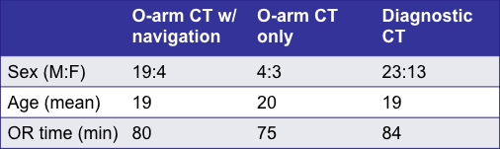  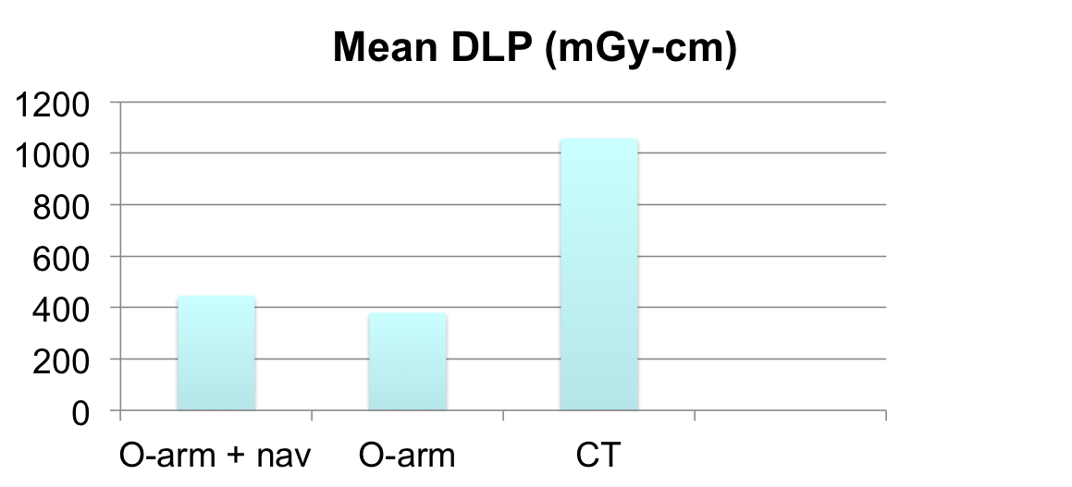 | Mention outcomes that the reference paper(s) and prior studies have verified here:  In the last video of this series I am going to discuss the results of the study (http://jbjs.org/article.aspx?articleid=1864382) we conducted to compare three different techniques of radiofrequency ablation. In the first group of patients, the O-arm was used with surgical navigation. In the second group, only the O-arm CT scan was used, without surgical navigation. In the third group, a diagnostic-quality CT scan in a radiology suite was used. We looked at the radiation exposure, which is especially important in this group of patients, of a pediatric and adolescent age. The radiation exposure was nearly twice as great for those undergoing the CT scan technique, as opposed to the O-arm with or without navigation. This difference was statistically significant.”
Survivorship curve  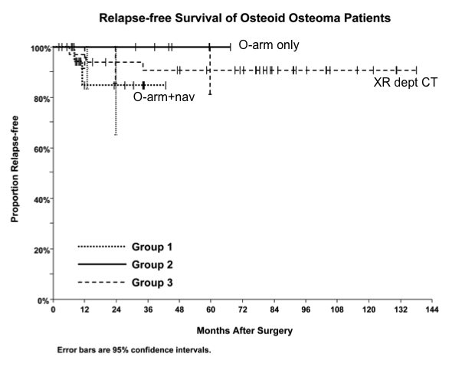 | “This survivorship curve demonstrates the outcome of treatment which is statistically the same regardless of which technique is used to target the lesion. Overall, 92% of patients were pain-free at a mean follow-up of 53 months. The vast majority of relapses will occur within the first year or two, as can be seen from this graph.”
Video File 15
Conclusions  - Intraoperative O-arm CT has ~ ½ the radiation exposure of the radiology suite based CT technique. This is especially important in the pediatric and adolescent age group.  - Intraoperative O-arm CT and conventional CT targeting techniques have similar outcomes with >90% success in relieving pain. | Provide accompanying narration here:  “Our study demonstrated that usage of an intraoperative O-arm CT scan can reduce the radiation exposure to the patient by approximately one-half. This is especially important in the pediatric and adolescent age group, in whom these tumors occur. The outcome of treatment is the same regardless of whether an intraoperative CT scan or conventional diagnostic-quality CT scan is used to target the nidus. Over 90% of the patients have successful relief of pain. Thank you for watching our instructional video. We hope that you’ve found it beneficial in helping your understanding, so that you may be able to perform this safely, effectively and efficiently.”
References (will appear as text beneath video)
Insert a list of references that support any statements made on the text slides and the outcomes of the procedure here:

After your storyboard has been approved, produce your Key Procedures video following the JBJS Author Video Guidelines (http://sites.jbjs.org/est/video_guidelines.html), with the following modifications:

  - Total video duration is typically ten to fifteen minutes
  - Author/institutional logos are acceptable only on the title and author slides/scenes
  - Do not place important visual concepts in the bottom-right corner at any point during the video as the JBJS logo will appear in that location
  - If possible, produce video in 16:9 aspect ratio
  - Submit separate video files for each substantive segment.
  - Include a Key Procedures Video File List with your submission.
  - We recommend encoding your video in an H.264 format such as MP4 or MOV. Other file formats, including avi, mpeg, mpg, and wmv, are acceptable.

