JBJS EST Video File List

Introduction and Example
JBJS Essential Surgical Techniques articles require a separate video file for each substantive segment. This enables viewers to click on the portion they want to see without having to watch the entire video, as in the following example:

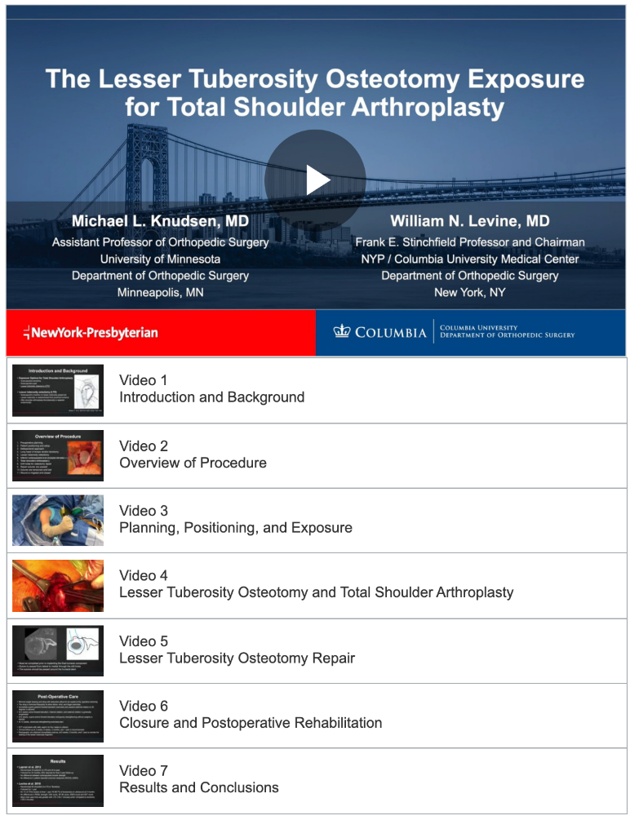

JBJS created the above video file list based on the form below, filled out by the authors:

 | Description of Video (100 characters maximum)†
Video 1 | Introduction and Background.
Video 2 | Overview of Procedure.
Video 3 | Planning, Positioning, and Exposure.
Video 4 | Lesser Tuberosity and Total Shoulder Arthroplasty.
Video 5 | Lesser Tuberosity Osteotomy Repair.
Video 6 | Closure and Postoperative Rehabilitation.
Video 7 | Results and Conclusions.

Instructions and Form
To enable viewers to click on the different portions of your procedure—i.e., to view the video showing that portion—please fill out the following form:

JBJS EST Article Title:

Author(s):

Description of Video (100 characters maximum)†
Video 1
Video 2
Video 3
Video 4
Video 5
Video 6
Video 7
Video 8
Video 9
Video 10
(add additional rows if >10 videos submitted)

†This will be the title of the video on which the viewer will click to view the portion of the procedure that the video shows.

Please contact editorial@surgicaltechniques.org with any questions.

